Boswa Farms Website Report
1. Introduction
The Boswa Farms website is a multi-page responsive web project designed using HTML, Bootstrap 5, and custom CSS. The purpose of the website is to showcase farm products, provide information about the farm, and allow users to navigate through different sections such as products, services, gallery, and contact information.
The website is structured to reflect a modern agricultural business presence online, focusing on clarity, simplicity, and accessibility.

2. Website Structure
The website consists of the following pages:
- Home (index.html) – Landing page introducing Boswa Farms and highlighting key products.
- About Page (about.html) – Provides background information about the farm and its mission.
- Products Page (products.html) – Displays farm produce and goods available.
- Services Page (services.html) – Describes services offered by the farm.
- Gallery Page (gallery.html) – Shows images of farm activities and products.
- Contact Page (contact.html) – Provides contact details and a form for inquiries.
The project also includes supporting folders:
- images/ – Stores all website images (logos, banners, product images).
- css/ – Contains custom styling (styles.css).

3. Technologies Used
The following technologies were used in the development of the website:
- HTML5 – For structuring web pages.
- CSS3 – For custom styling and layout adjustments.
- Bootstrap 5.3 – For responsive design and prebuilt components such as navbar, grid system, and cards.
- GitHub Pages (optional deployment) – For hosting the website online.
Bootstrap was used via CDN (Content Delivery Network), allowing quick integration without installing external files.

4. Features
The website includes the following features:
- Responsive navigation bar across all pages
- Mobile-friendly layout using Bootstrap grid system
- Image-based product cards
- Consistent footer across pages
- Organized folder structure for maintainability
- Interactive buttons and links between pages

5. Challenges Encountered
During development, several challenges were experienced:
- Difficulty uploading and organizing images into the correct GitHub folders
- Broken image links due to incorrect file paths
- Confusion with GitHub folder creation (images folder not appearing initially)
- Ensuring consistency across multiple pages
- Aligning the website layout to match the original wireframe design
These challenges were resolved through correct use of file paths and structured folder naming conventions.

6. Future Improvements
The following improvements can be made to enhance the website in the future:
6.1 Functional Improvements
- Add a working contact form using backend services (e.g., PHP, Node.js, or Formspree)
- Implement a shopping cart system for ordering farm products
- Add search functionality for products
6.2 Design Improvements
- Improve image quality and consistency across all pages
- Add animations and transitions for better user experience
- Enhance mobile responsiveness for smaller devices
6.3 Content Improvements
- Add more detailed product descriptions and pricing
- Include seasonal updates for available farm produce
- Add testimonials from customers
6.4 Technical Improvements
- Optimize images for faster loading speed
- Improve SEO (Search Engine Optimization) for better visibility
- Add database integration for dynamic content in future versions

7. Conclusion
The Boswa Farms website successfully demonstrates the use of HTML, CSS, and Bootstrap to create a responsive and structured multi-page website. It serves as a strong foundation for a digital agricultural platform.
With further development, the website can evolve into a fully functional e-commerce and farm management system.

8. Reflection
This project improved understanding of web development concepts such as file structure management, responsive design, and version control using GitHub. It also highlighted the importance of proper organization when working with images and multi-page websites.

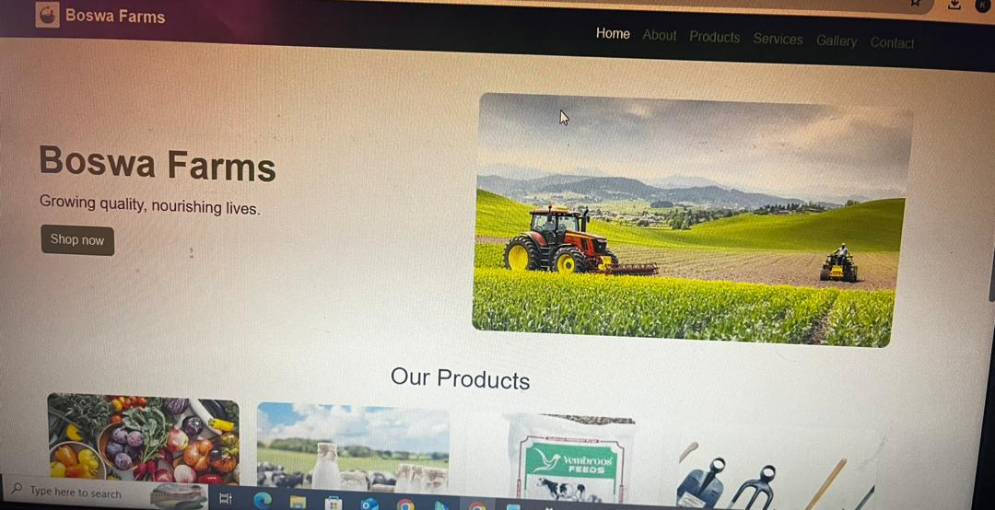Screen
